LAB-PROGRAM

- Write a program to Print Fibonacci Series using recursion.
AIM:
To write a C program to print Fibonacci series using recursion.
Algorithm:
- Start.
- Read number of terms $n$.
- Define a recursive function to generate Fibonacci numbers.
- Use a loop to print Fibonacci numbers.
- Stop.
Code:
#include <stdio.h>
int fibonacci(int n) {
if (n <= 1)
return n;
return fibonacci(n - 1) + fibonacci(n - 2);
}
int main() {
int n, i;
printf("Enter number of terms: ");
scanf("%d", &n);
printf("Fibonacci Series:\n");
for (i = 0; i < n; i++) {
printf("%d ", fibonacci(i));
}
return 0;
}
Output:
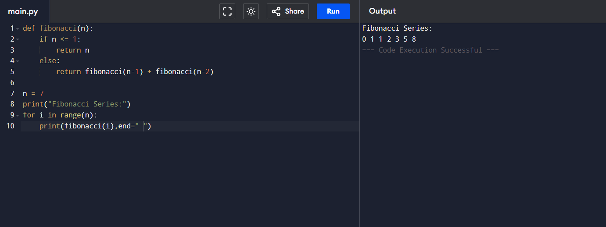
- Write a program to check the given no is Armstrong or not.
AIM:
To write a C program to check if a number is Armstrong or not.
Algorithm:
- Start.
- Read a number.
- Count its digits.
- Compute sum of digits raised to the power of number of digits.
- Compare sum to original number.
- Print result.
- Stop.
Code:
#include <stdio.h>
#include <math.h>
int main() {
int num, temp, digits = 0, sum = 0, rem;
printf("Enter a number: ");
scanf("%d", &num);
temp = num;
while (temp != 0) {
digits++;
temp /= 10;
}
temp = num;
while (temp != 0) {
rem = temp % 10;
sum += pow(rem, digits);
temp /= 10;
}
if (sum == num)
printf("Armstrong Number\n");
else
printf("Not an Armstrong Number\n");
return 0;
}
Output:
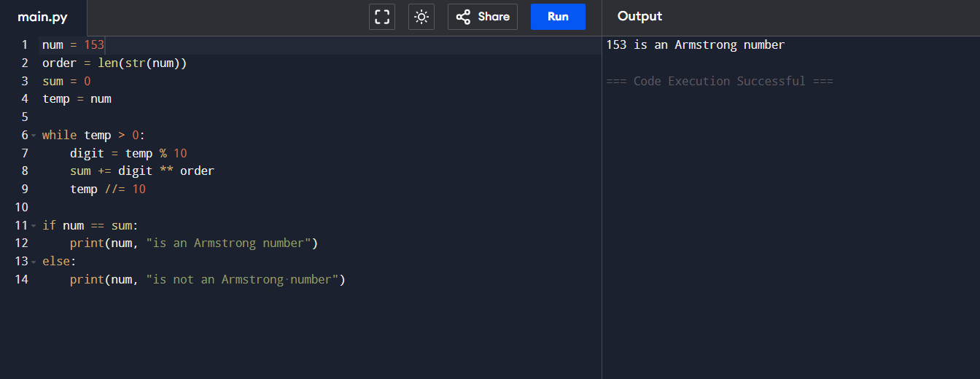 3.Write a program to find the GCD of two numbers .
AIM:
To write a C program to find GCD of two numbers using recursion.
Algorithm:
- Start.
- Read two numbers.
- Use recursion to compute GCD.
- Print result.
- Stop.
Code:
#include <stdio.h>
int gcd(int a, int b) {
if (b == 0)
return a;
return gcd(b, a % b);
}
int main() {
int x, y;
printf("Enter two numbers: ");
scanf("%d %d", &x, &y);
printf("GCD is %d\n", gcd(x, y));
return 0;
}

Output:
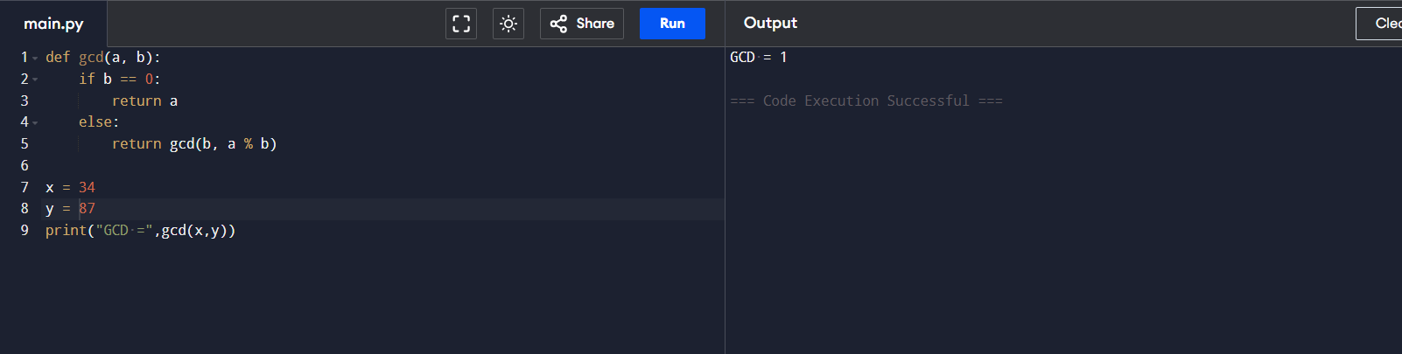
4.Write a program to get the largest element of an array.
AIM:
To find and print the largest element of an array.
Algorithm:
- Start.
- Read number of elements.
- Read array elements.
- Initialize max to first element.
- Loop to compare each element; update max as needed.
- Print max.
- Stop.

Code:
#include <stdio.h>
int main() {
int n, i, max;
printf("Enter number of elements: ");
scanf("%d", &n);
int arr[n];
printf("Enter array elements:\n");
for (i = 0; i < n; i++)
scanf("%d", &arr[i]);
max = arr[0];
for (i = 1; i < n; i++)
if (arr[i] > max)
max = arr[i];
printf("Largest element is %d\n", max);
return 0;
}
Output:
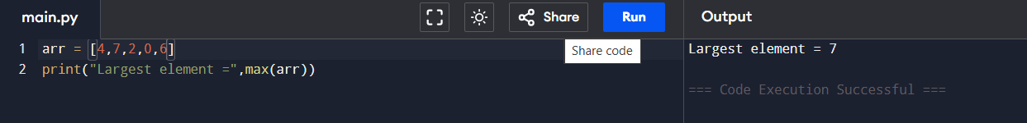
5.Write a program to find the Factorial of a number .
AIM:
To write a C program to find the factorial of a given number using recursion.
Algorithm:
- Start.
- Read a number n.
- Define a recursive function to calculate factorial.
- Print the result.
- Stop.

Code:
#include <stdio.h>
int factorial(int n) {
if (n == 0 || n == 1)
return 1;
return n * factorial(n - 1);
}
int main() {
int n;
printf("Enter a number: ");
scanf("%d", &n);
printf("Factorial of %d is %d\n", n, factorial(n));
return 0;
}
Output:
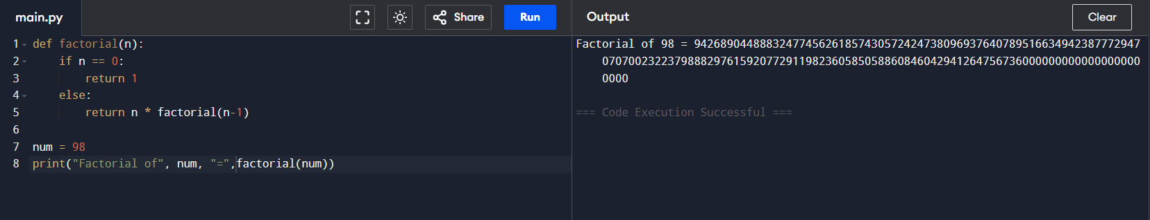
- Write a program to check a number is a prime number or not .
AIM:
To write a C program to check if a number is prime.
Algorithm:
- Start.
- Read a number n.
- Check if n is less than or equal to 1.
- For each number i from 2 to n/2, check if n is divisible by i.
- Print if prime or not.
- Stop.

Code:
#include <stdio.h>
int main() {
int n, i, flag = 0;
printf("Enter a number: ");
scanf("%d", &n);
if (n <= 1) flag = 1;
for (i = 2; i <= n / 2; i++) {
if (n % i == 0) {
flag = 1;
break;
}
}
if (flag == 0)
printf("%d is a prime number\n", n);
else
printf("%d is not a prime number\n", n);
return 0;
}

Output:
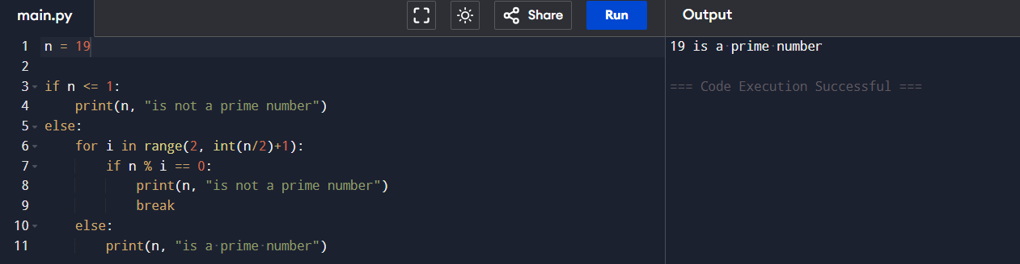
- Write a program to perform Selection sort.
AIM:
To write a C program to perform selection sort on an array.
Algorithm:
- Start.
- Read array size and elements.
- For each position in the array, find the minimum element in the unsorted portion and swap.
- Repeat until sorted.
- Print sorted array.
- Stop.

Code:
#include <stdio.h>
int main() {
int n, i, j, min, temp;
printf("Enter number of elements: ");
scanf("%d", &n);
int arr[n];
printf("Enter array elements:\n");
for (i = 0; i < n; i++)
scanf("%d", &arr[i]);
for (i = 0; i < n - 1; i++) {
min = i;
for (j = i + 1; j < n; j++)
if (arr[j] < arr[min])
min = j;
temp = arr[i];
arr[i] = arr[min];
arr[min] = temp;
}
printf("Sorted array:\n");
for (i = 0; i < n; i++)
printf("%d ", arr[i]);
return 0;
}

Output:
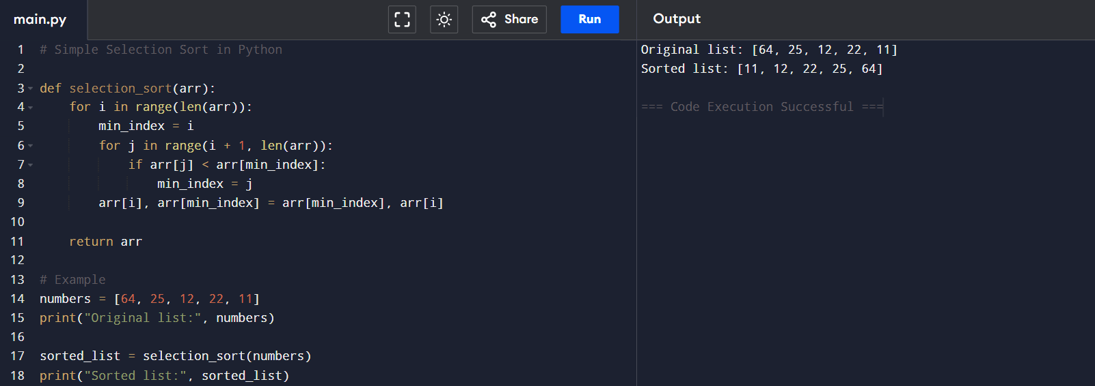
- Write a program to perform Bubble sort.
AIM:
To write a C program to perform bubble sort on an array.
Algorithm:
- Start.
- Read array size and elements.
- For each element, compare with the next and swap if needed.
- Repeat until sorted.
- Print sorted array.
- Stop.

Code:
#include <stdio.h>
int main() {
int n, i, j, temp;
printf("Enter number of elements: ");
scanf("%d", &n);
int arr[n];
printf("Enter array elements:\n");
for (i = 0; i < n; i++)
scanf("%d", &arr[i]);
for (i = 0; i < n - 1; i++)
for (j = 0; j < n - i - 1; j++)
if (arr[j] > arr[j + 1]) {
temp = arr[j];
arr[j] = arr[j + 1];
arr[j + 1] = temp;
}
printf("Sorted array:\n");
for (i = 0; i < n; i++)
printf("%d ", arr[i]);
return 0;
}
Output:
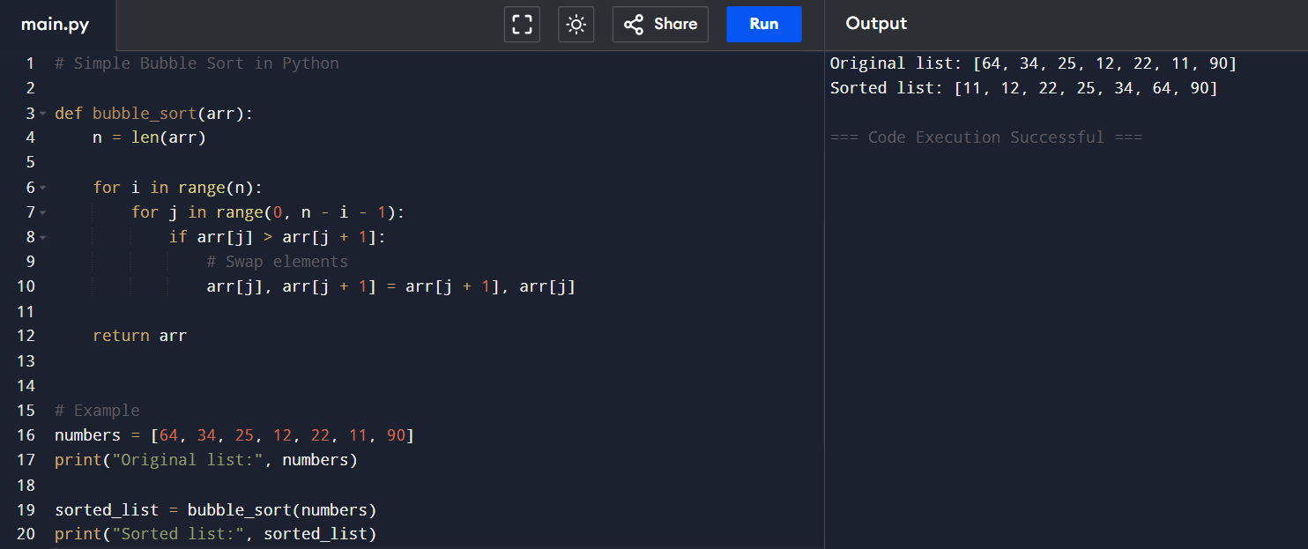
- Write a program for to multiply two Matrix.
Aim:
To multiply two matrices and display the resultant matrix.
Algorithm:
- Start
- Read number of rows and columns for the first matrix (r1, c1)
- Read number of rows and columns for the second matrix (r2, c2)
- Check if column of first matrix (c1) is equal to row of second matrix (r2). If not, multiplication is not possible.
- Read elements of the first matrix and second matrix.
- Initialize a result matrix with dimensions r1 x c2 with all elements as 0.
- Multiply matrices using nested loops:
For i = 0 to r1-1
For j = 0 to c2-1
For k = 0 to c1-1
result[i][j] += matrix1[i][k] * matrix2[k][j]
- Display the resultant matrix.
- Stop

Code:
#include <stdio.h>
int main() {
int r1, c1, r2, c2, i, j, k;
int matrix1[10][10], matrix2[10][10], result[10][10];
printf("Enter rows and columns for first matrix: ");
scanf("%d %d", &r1, &c1);
printf("Enter rows and columns for second matrix: ");
scanf("%d %d", &r2, &c2);
if (c1 != r2) {
printf("Matrix multiplication not possible.\n");
return 0;
}
printf("Enter elements of first matrix:\n");
for (i = 0; i < r1; i++) {
for (j = 0; j < c1; j++) {
scanf("%d", &matrix1[i][j]);
}
}
printf("Enter elements of second matrix:\n");
for (i = 0; i < r2; i++) {
for (j = 0; j < c2; j++) {
scanf("%d", &matrix2[i][j]);
}
}
for (i = 0; i < r1; i++) {
for (j = 0; j < c2; j++) {
result[i][j] = 0;
}
}
for (i = 0; i < r1; i++) {
for (j = 0; j < c2; j++) {
for (k = 0; k < c1; k++) {
result[i][j] += matrix1[i][k] * matrix2[k][j];
}
}
}
printf("Resultant matrix after multiplication:\n");
for (i = 0; i < r1; i++) {
for (j = 0; j < c2; j++) {
printf("%d ", result[i][j]);
}
printf("\n");
}
return 0;
}
Output:
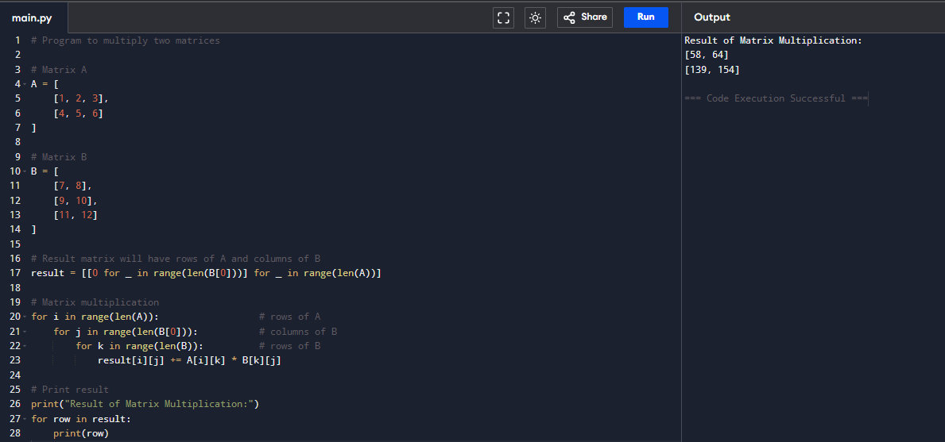
- Write a program for to check whether a given String is Palindrome or not.
Aim:
To check whether a given string is a palindrome or not.
Algorithm:
- Start
- Read the input string.
- Initialize two indices, start=0 and end=length_of_string - 1.
- Compare characters at start and end position.
- If characters are equal, increment start and decrement end; repeat step 4 until start >= end.
- If any character pair mismatches, the string is not a palindrome.
- If all pairs match, string is a palindrome.
- Print the result.
- Stop
Code:
#include <stdio.h>
#include <string.h>
int main() {
char str[100];
int start = 0, end, flag = 1;
printf("Enter a string: ");
gets(str);
end = strlen(str) - 1;
while (start < end) {
if (str[start] != str[end]) {
flag = 0;
break;
}
start++;
end--;
}
if (flag)
printf("The string is a palindrome.\n");
else
printf("The string is not a palindrome.\n");
return 0;
}

Output:
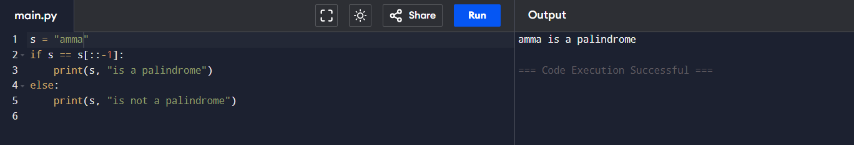
- Write a program for to copy one string to another.
Aim:
To copy one string into another string.
Algorithm:
- Start
- Take input string from the user.
- Copy each character from source string to destination string until the null character is encountered.
- Add the null character at the end of the destination string.
- Print the copied string.
- Stop.

Code:
#include <stdio.h>
int main() {
char str1[100], str2[100];
int i = 0;
printf("Enter a string: ");
fgets(str1, sizeof(str1), stdin);
while (str1[i] != '\0') {
str2[i] = str1[i];
i++;
}
str2[i] = '\0';
printf("Copied string: %s", str2);
return 0;
}
Output:
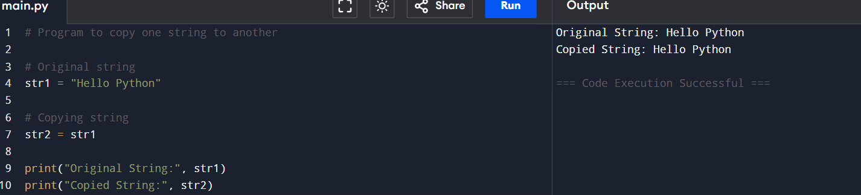

- Write a Program to perform binary search.
Aim:
To perform binary search on a sorted array to find a target element.
Algorithm:
- Start
- Take sorted array input and target element.
- Initialize low = 0, high = size-1.
- Find mid = (low + high)/2.
- If arr[mid] is the target, print index and stop.
- If arr[mid] < target, set low = mid + 1, else high = mid -1.
- Repeat steps 4-6 until low > high.
- If element not found, print not found message.
- Stop.
Code:
#include <stdio.h>
int binarySearch(int arr[], int size, int target) {
int low = 0, high = size - 1;
while (low <= high) {
int mid = low + (high - low) / 2;
if (arr[mid] == target)
return mid;
else if (arr[mid] < target)
low = mid + 1;
else
high = mid - 1;
}
return -1;
}
int main() {
int arr[] = {2, 5, 8, 12, 16, 23, 38, 56, 72, 91};
int size = sizeof(arr) / sizeof(arr[0]);
int target = 23;
int result = binarySearch(arr, size, target);
if (result != -1)
printf("Element found at index %d\n", result);
else
printf("Element not found\n");
return 0;
}
Output:
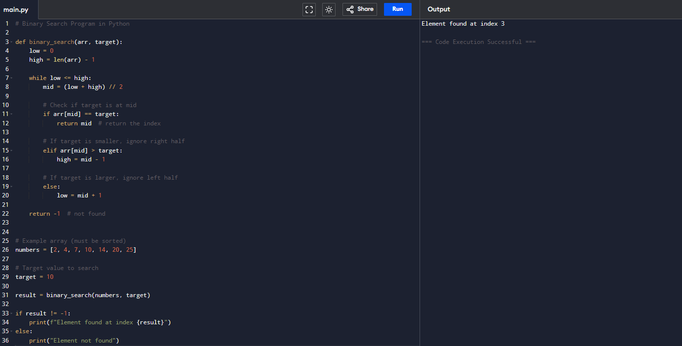
- Write a program to print the reverse of a string.
Aim:
To print the reverse of a given string.
Algorithm:
- Start
- Read the string.
- Find length of the string.
- Use a loop to print characters from the last to first.
- Stop.

Code:
#include <stdio.h>
#include <string.h>

int main() {
char str[100];
int i, length;
printf("Enter a string: ");
fgets(str, sizeof(str), stdin);
length = strlen(str);
if(str[length-1] == '\n') {
str[length-1] = '\0';
length--;
}
printf("Reversed string: ");
for (i = length - 1; i >= 0; i--) {
printf("%c", str[i]);
}
printf("\n");
return 0;
}
Output:
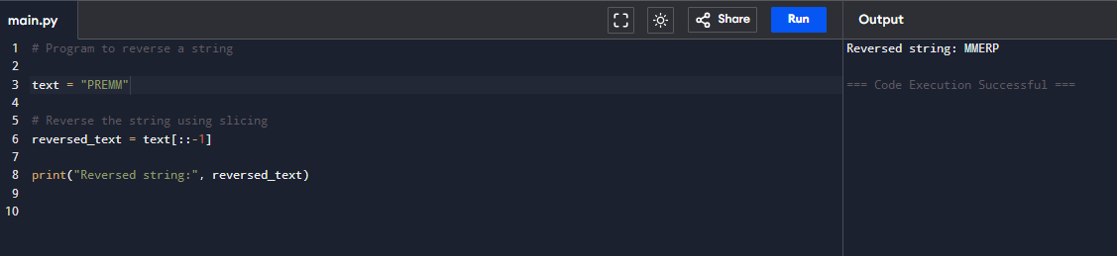
- Write a program to find the length of a string.

AIM:
To find the length of a string without using library function.

ALGORITHM:
Read string
Initialize count = 0
Traverse until NULL character
Increment count
Display count
Code:
#include <stdio.h>
int main() {
char s[100];
int len=0;
printf("Enter string: ");
gets(s);
while(s[len] != '\0') len++;
printf("Length: %d", len);
}
Output:
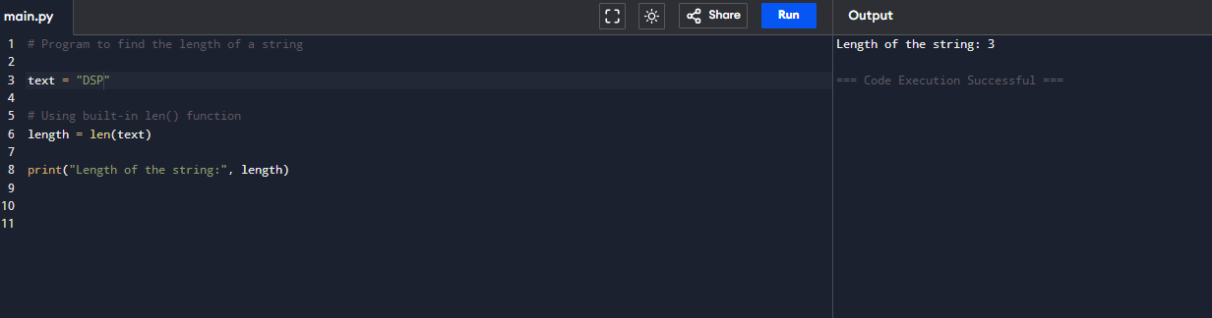

- Write a program to perform Strassen’s Matrix Multiplication.

AIM:
To multiply two matrices using Strassen's technique.

ALGORITHM:
Divide both matrices into sub-matrices
Calculate 7 intermediate products
Combine results to form resultant matrix
Code:
#include <stdio.h>
int main() {
int A[2][2], B[2][2], C[2][2];
int p1,p2,p3,p4,p5,p6,p7;

printf("Enter Matrix A: ");
for(int i=0;i<2;i++)
for(int j=0;j<2;j++) scanf("%d",&A[i][j]);

printf("Enter Matrix B: ");
for(int i=0;i<2;i++)
for(int j=0;j<2;j++) scanf("%d",&B[i][j]);

p1 = (A[0][0]+A[1][1])*(B[0][0]+B[1][1]);
p2 = (A[1][0]+A[1][1])*B[0][0];
p3 = A[0][0]*(B[0][1]-B[1][1]);
p4 = A[1][1]*(B[1][0]-B[0][0]);
p5 = (A[0][0]+A[0][1])*B[1][1];
p6 = (A[1][0]-A[0][0])*(B[0][0]+B[0][1]);
p7 = (A[0][1]-A[1][1])*(B[1][0]+B[1][1]);

C[0][0]=p1+p4-p5+p7;
C[0][1]=p3+p5;
C[1][0]=p2+p4;
C[1][1]=p1-p2+p3+p6;

printf("Result Matrix:\n");
for(int i=0;i<2;i++){
for(int j=0;j<2;j++) printf("%d ",C[i][j]);
printf("\n");
}
}

Output:
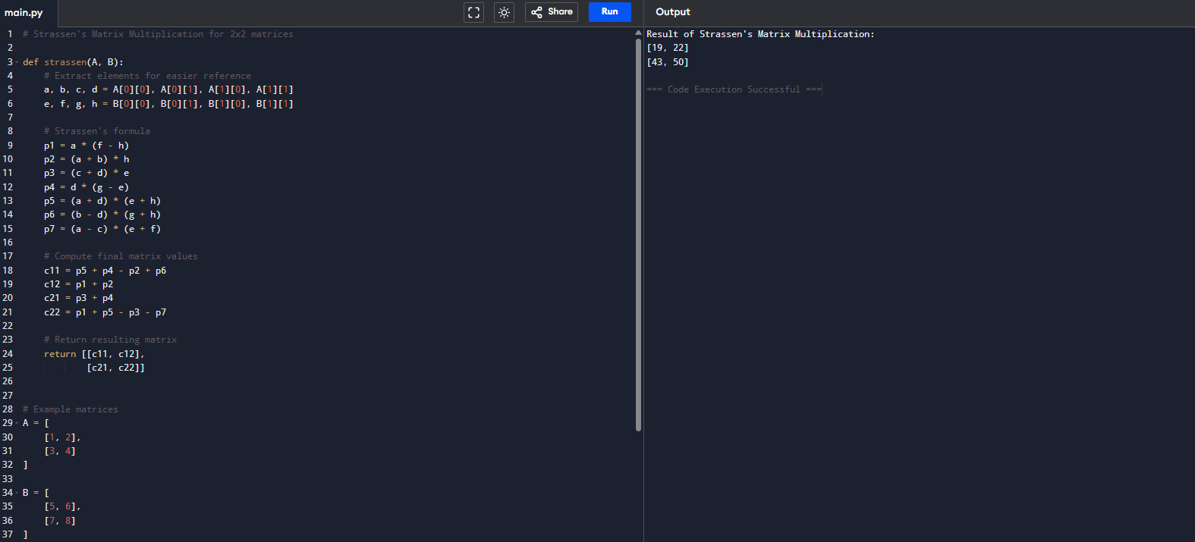
- Write a program to perform Merge Sort.

AIM:
To sort an array using Merge Sort algorithm.

ALGORITHM:
Divide array into halves
Sort each half recursively
Merge sorted halves
Code:
#include <stdio.h>
void merge(int a[], int l, int m, int r){
int i=l,j=m+1,k=0,temp[100];
while(i<=m && j<=r)
temp[k++] = (a[i]<a[j])?a[i++]:a[j++];
while(i<=m) temp[k++]=a[i++];
while(j<=r) temp[k++]=a[j++];
for(i=l,k=0;i<=r;i++) a[i]=temp[k++];
}

void mergesort(int a[], int l, int r){
if(l<r){
int m=(l+r)/2;
mergesort(a,l,m);
mergesort(a,m+1,r);
merge(a,l,m,r);
}
}

int main(){
int a[10], n;
scanf("%d",&n);
for(int i=0;i<n;i++) scanf("%d",&a[i]);
mergesort(a,0,n-1);
for(int i=0;i<n;i++) printf("%d ",a[i]);
}
Output:

- Using Divide and Conquer strategy to find Max and Min value in the list.

AIM:
To find maximum and minimum values using Divide and Conquer.

ALGORITHM:
Divide list into two halves
Find max and min of each half
Compare and combine results
Code:
#include <stdio.h>
int maxMin(int a[], int l, int r, int *max, int *min){
if(l==r){
*max=*min=a[l];
} else {
int mid=(l+r)/2, max1,min1;
maxMin(a,l,mid,max,min);
maxMin(a,mid+1,r,&max1,&min1);
if(max1>*max) *max=max1;
if(min1<*min) *min=min1;
}
}
int main(){
int a[10],n,max,min;
scanf("%d",&n);
for(int i=0;i<n;i++) scanf("%d",&a[i]);
maxMin(a,0,n-1,&max,&min);
printf("Max=%d Min=%d",max,min);
}
Output:
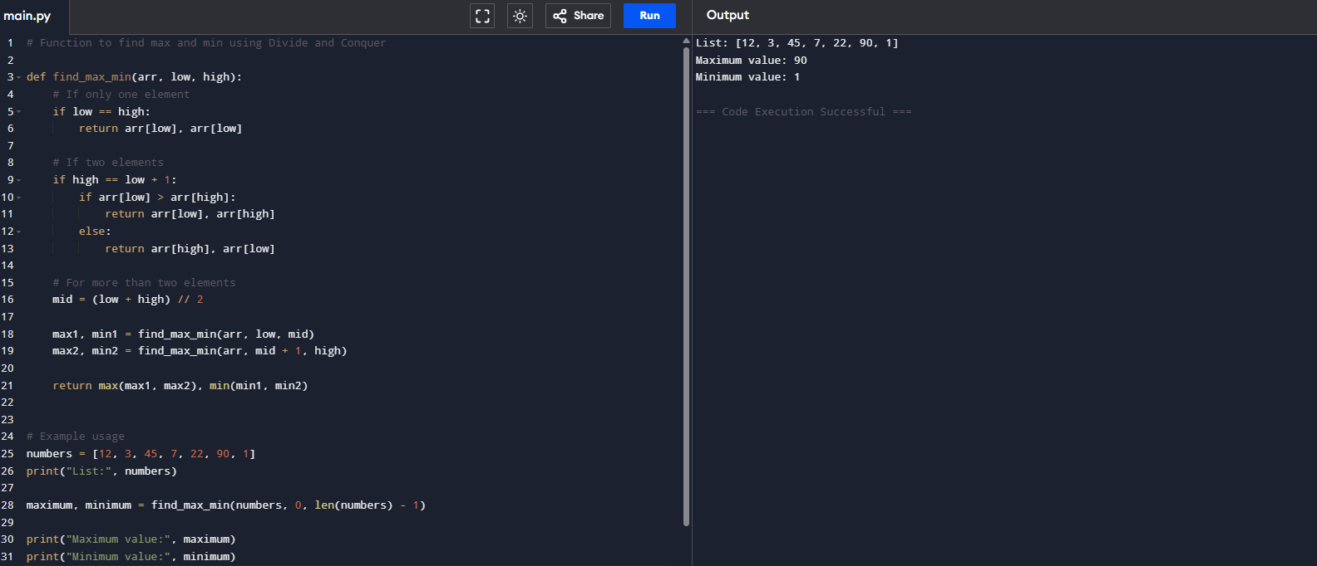
- Write a program to generate all the prime numbers.

AIM:
To generate all prime numbers up to N.

ALGORITHM:
Read N
For each number from 2 to N
Check divisibility
If prime, print
Code:
#include <stdio.h>
int main(){
int n,i,j,flag;
scanf("%d",&n);
for(i=2;i<=n;i++){
flag=1;
for(j=2;j<i;j++)
if(i%j==0) flag=0;
if(flag) printf("%d ",i);
}
}
Output:
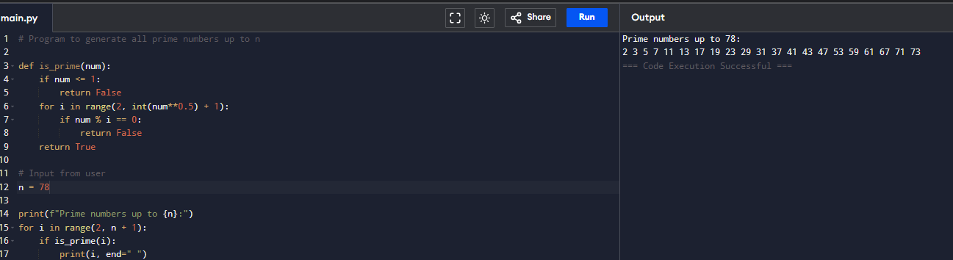
- Write a program to perform Knapsack problem using greedy techniques.
Aim:
To solve fractional knapsack problem using greedy approach.

ALGORITHM:
Input weights and profits
Sort by profit/weight ratio
Select items until capacity is full
Code:
#include <stdio.h>
int main(){
int n,cap,i;
float profit=0;
scanf("%d %d",&n,&cap);
int w[10], p[10];
for(i=0;i<n;i++) scanf("%d %d",&w[i],&p[i]);

for(i=0;i<n;i++){
if(w[i]<=cap){
profit+=p[i];
cap-=w[i];
}
}
printf("Max Profit: %.2f",profit);
}
Output:
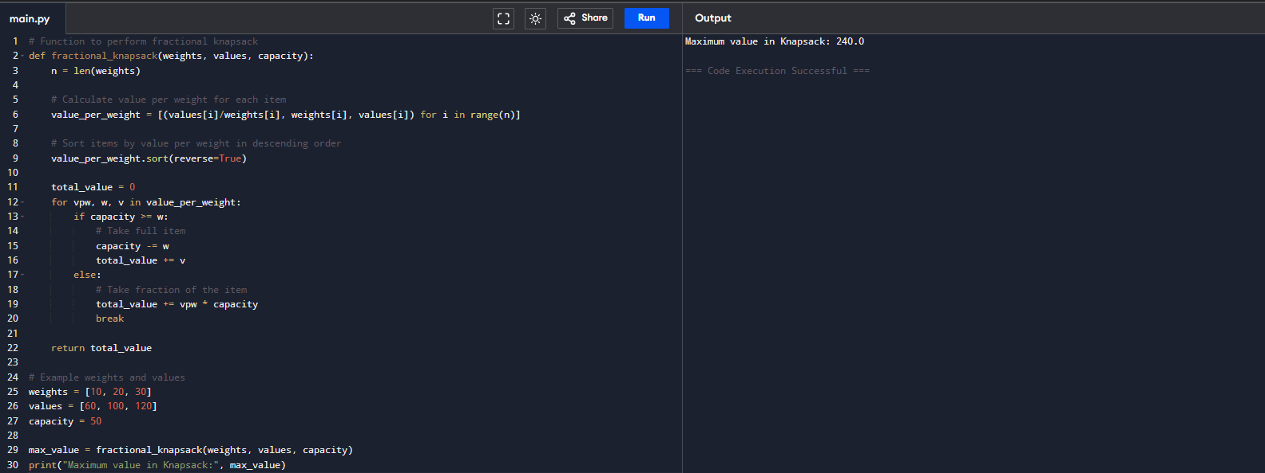
- Write a program to perform MST using greedy techniques.

AIM:
To find Minimum Spanning Tree of a graph using greedy technique.

ALGORITHM:
Read adjacency matrix
Select smallest edge
Check for cycle
Add edge to MST
Repeat until n-1 edges
Code:
#include <stdio.h>
int parent[10];

int find(int i){
while(parent[i])
i=parent[i];
return i;
}
int uni(int i,int j){
if(i!=j){
parent[j]=i;
return 1;
}
return 0;
}
int main(){
int n,i,j,min,a,b,u,v;
int cost[10][10];
scanf("%d",&n);
for(i=1;i<=n;i++)
for(j=1;j<=n;j++)
scanf("%d",&cost[i][j]);

int ne=1,mincost=0;
while(ne<n){
min=999;
for(i=1;i<=n;i++)
for(j=1;j<=n;j++)
if(cost[i][j]<min){
min=cost[i][j]; a=u=i; b=v=j;
}
u=find(u); v=find(v);
if(uni(u,v)){
printf("%d edge (%d,%d) cost=%d\n",ne++,a,b,min);
mincost+=min;
}
cost[a][b]=cost[b][a]=999;
}
printf("Min Cost=%d",mincost);
}
Output:
